

Dept. Of Industrial Engineering and Management

HoNey and neonic pesticides

**Brief Technical Report for Engineers**

**Presented to: Dr. Ori Nissim Levy**

**By: Uriya Sela**

**Date: 23/12/2021**

**Table of Content:**

Abstract ----------------------------------------------------------------------------------------------------------- page 3

Introduction ------------------------------------------------------------------------------------------------------ page 3

Methods ---------------------------------------------------------------------------------------------------------- page 4

Result -------------------------------------------------------------------------------------------------------------- page 8

Discussion --------------------------------------------------------------------------------------------------------- page 9

Conclusion ------------------------------------------------------------------------------------------------------- page 10

References ------------------------------------------------------------------------------------------------------ page 10

**\**

**Abstract**

**The project was done in order to find insights that will help the honey and beehives market; the tools that have been used are Pandas in Jupyter lab using Python.**

**The main methods were finding correlations and looking for interesting information that could help identify interesting insights.**

**The analysis showed several findings, such as how to make to business in the honey market more profitable and suggest other directions for research in that field, regarding the usage of neonic pesticides.**

**Introduction**

Neonicotinoids (neonics) are the most widely used insecticides in the world. They are used in field crops, orchard, pets and beehives. Bees are very important to the growth and the development of our world. The purpose of the project is to check more deeply how neonics affect the beehives and honey production around the world. As we know, “Neonicotinoid seed dressings have caused concern world-wide”[1] and one of the project’s aims is to find how to reduce the use of the neonics.

The analysis was done in order to find insights that will help the honey and beehives market. We used a dataset that was taken from ‘Kaggle’ website; the dataset is inspired by the Honey Production in the USA dataset, which examined to the period of 1998-2017.

The project produced interesting correlations and surprising insights, such as how the stocks and the market reacted to the usage of neonics in beehives and suggested a reason why honey has got so expensive during the past 10 years.

**METHODS**

**Organization of the data**

The data includes information such as: the number of colonies (numcol), yield per colony (yieldpercol), total production (totalprod), stocks. average price per pound based on expanded sales (priceperlb), value of production (prodvalue) and neonic pesticides.

At the first stage, in order to read the data, it needed to be organized; therefore, the data needed to be more legible and clearer than just in a csv file so it is presented in a dataframe.

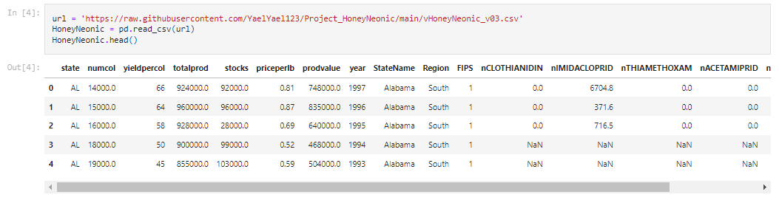

**Fig. 1.** First 5 rows of the data

There was a problem with the data because there were a few columns with missing values but the info command let one see which the ‘problematic’ values are.

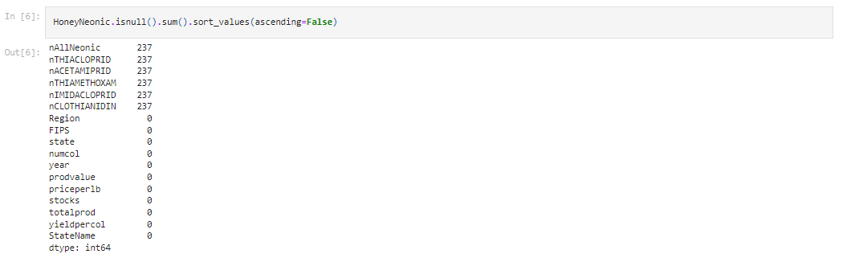

**Fig. 2.** The columns with the Non value

It can be seen that all of the missing values are in the Neonic Pesticides columns. After looking into the rows of the missing values we realized that the values are missing only because the research was started before the farmers started using the neonic pesticides. Therefore, it was decided to change them into 0.



**Fig. 3.** Changing the Non values to 0

**Understanding the data**

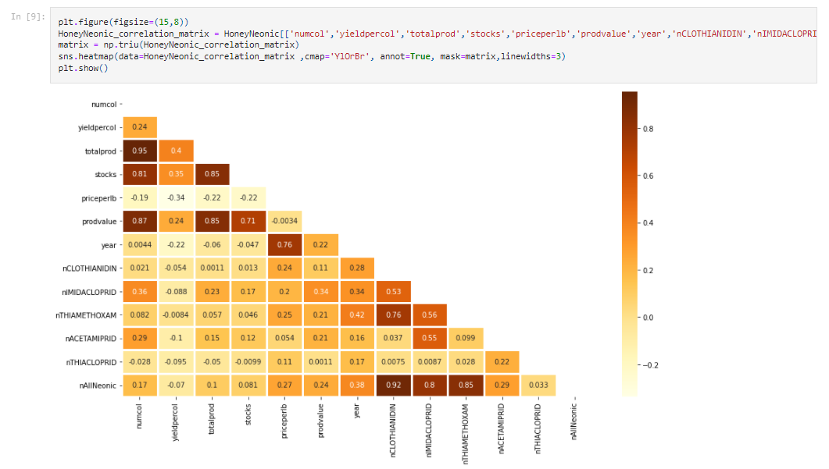In terms of understanding the data, it is necessary to find correlations between the columns. The yellow and brown colours were chosen to relate the relevant information.

**Fig. 4.** Correlations of the columns of the dataset

There is a correlation between the stock’s value, the number of colonies and the total production.

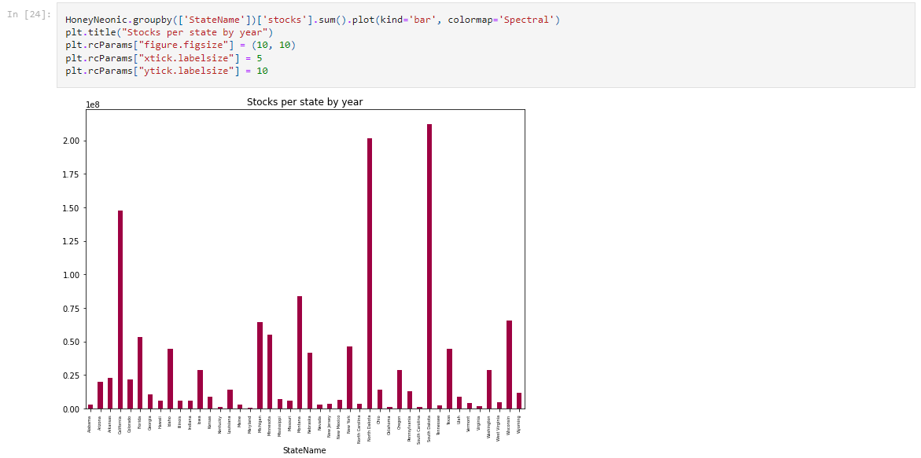There was a need to check the data more thoroughly, so a comparison between the states in the US was deemed to be in appropriate tool for looking for correlations.

**Fig. 5.** Stocks per state by year

North Dakota is the state that the project focuses on.

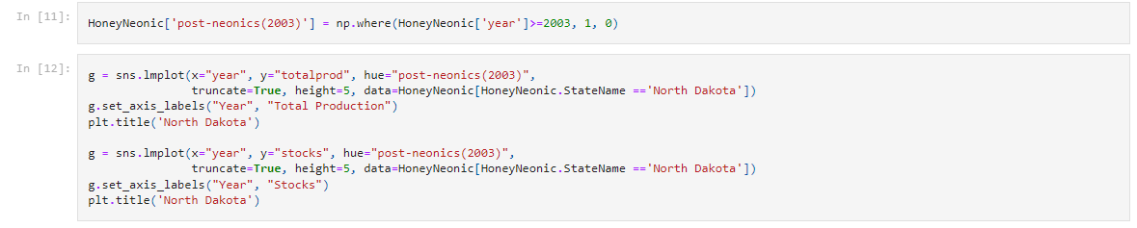The project shows how North Dakota has behaved throughout the years:

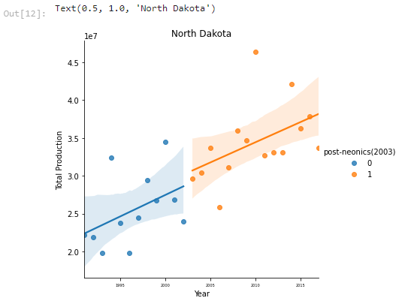

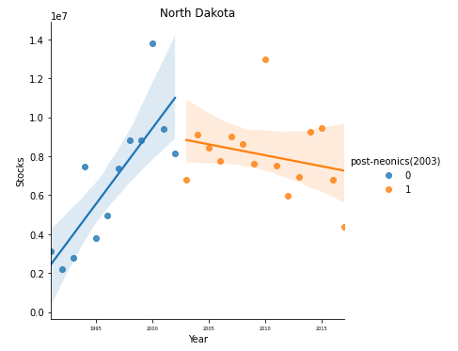

**Fig. 6.** Total production and stocks per year

The analysis shows (in the right graph) the linear regression between the total production and the years, while in the left graph we can see the linear regression between the stocks and the years. The graphs indicate that until 2013, before using the neonic pesticides, there was an increase in the total production and the stocks, while after 2013, when neonic pesticides were brought into use, the total production kept increasing but the stocks went down. (Which was unexpected because using the neonic pesticides should have had positive effects on the market).

In the research,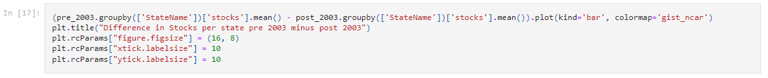 the different averages of the stocks’ value before and after using the neonic pesticides, were found.

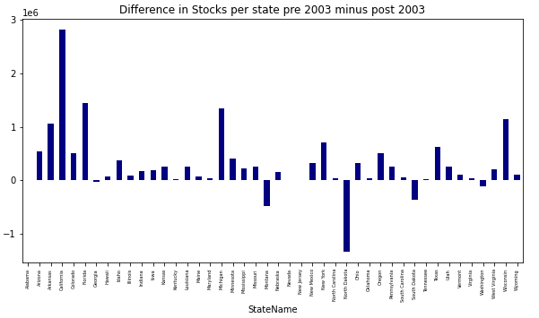

**Fig. 7.** Difference in stocks per state pre2003 minus post 2003

The analysis shows that there were four states that had a negative difference (increase) but the total effect was negative, which means that although there was no real decrease in the production - there was an effect on investments.

After the research shows that the stocks’ value went down while apparently it was supposed to go up (because of the usage of the neonic pesticides), it is necessary to check whether or not the neonic pesticides cause the decrease in the number of colonies, and how it effected the honey production of each colony.



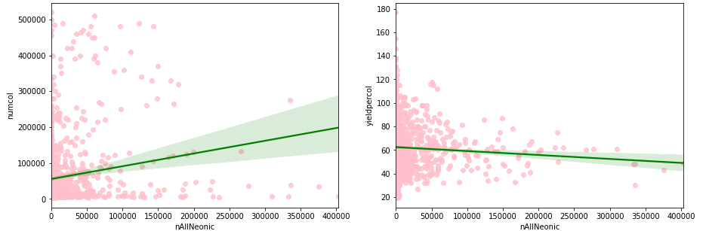

**Fig. 8.** subplot of the number of colonies and yield to neonics

In the left graph one can see that the more the usage of neonic pesticides increases so does that the number of colonies. However, in the graph on the right one can see that the more the usage of neonic pesticides increases, the production per colony decreases. Meaning that because due to greater use of neonic pesticides, and although the number of colonies still rose because most of the states have revived colonies that had died, the total production decreased as opposed to the increase in the number of colonies. Therefore, the effect of the pesticides was significant in the amount of honey produced per colony – because it caused the actual decrease in the production.

The research indicated that production in total increased over the years, so the question is raised; what happens to the cost of honey in the market in correlation to the findings above.

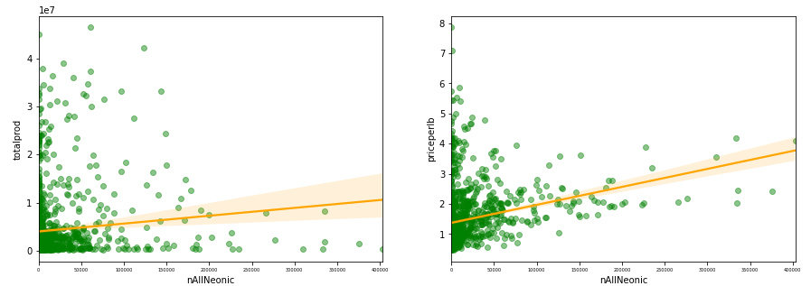

**Fig. 9.** Subplot of the price of the honey and the total production to the usage of neonics

The graphs indicate that there is a certain correlation between the price of honey and the total production in terms of the neonic pesticide usage.

Because there is a correlation, we wanted to see how the price increases over the year:

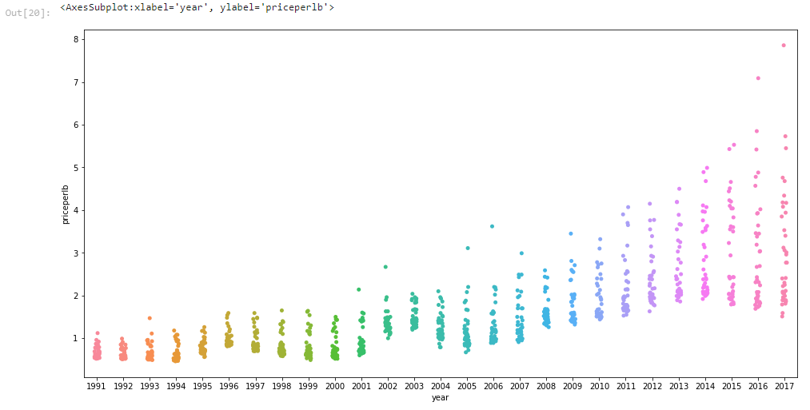

**Fig. 10.** Stripplot of the prices

The graph illustrates the increase in the price of the honey; the prices used to be much lower than what people can find today on the shelf. We can assume that it is caused inter alia because of the neonic pesticides.

**reSults**

Firstly, the data was examined in order to clarify what happens to the value of shares in light of the increase in the use of the neonic pesticides. the study focus on what was done before 2003 and after 2003 and (when a significant change in the use of neonic pesticides was made). It is apparent that the value of shares before 2003 increased while after 2003 the number of shares decreased.

Secondly, the data showed that the total amount of honey production from the colonies also increased (which was unusual because then the stocks were supposed to go up) which we found strange because the neonic pesticides hurt the bees. The research showed that the number of colonies (which increases) had a more significant effect than the production per colony.

Thirdly, the price of honey has skyrocketed (the minimum after 2003 is the maximum before 2003) in light of the increase in its quantity; this is because the "factories" (number of colonies) is larger and more colonies need to be maintained.

**discussion**

The main findings the analysis extracts from the data were that the change of policy regarding using neonic pesticides in 2003 had a significant impact on the market and the honey’s industry. It was also found that there was a contradiction between the size of the market to the stocks. This required investigation to check what the reason for this contradiction is, which led to the conclusion that the more one uses neonic pesticides, one reduces the number of bees per colony. finally, it was dicovered that in correlation to the expansion of the industry, the cost of honey went up.

The project assumes that the industry started using neonic pesticides to expand the market and make more money (we didn’t conduct research on this). One can see that the choice to use neonic pesticides was not bad, it really caused an expansion in the market. The research shows that there are many more colonies today than before 2003. The project raised the following questions: does the industry really make more money and if so, how can they make even more? And how will it effect the market and the honey consumers?

To answer the first question, the project needed to focus on the stocks’ movements, how the market grew and effect on the business model. According to the findings, one could say that the industry chose to focus on expanding and increasing the number of colonies in terms of producing more honey and therefore selling more honey. The research can say the market has grown but the stocks have gone down. In addition, the research shows that because of the reduction in the number of bees per colony, more resources had to be invested in facilities rather than pure honey production.

To answer the second question, the project has to deal with the issue of supply and demand. In the research the issue of supply was discussed. It is apparent that once the industry reduces the price and the production cost of the honey, the price of honey will go down and the consumers will enjoy ‘cheaper’ honey.

**conclusions**

In the project we tryed to review the honey industry and the effect of neonic pesticides usage.

It was found that there was a turning point in 2003, when the industry started using neonic pesticides. It affected the size of the market and the price of the honey.

There is still research to be done and solutions for the various issues to be addressed.

The study shows very clear correlations and directs the researchers towards specific fields on which to focus.

The study can be used in many fields that are looking to invest and improve the honey market. The study can also be used for those who are trying to fight against neonic pesticides usage and maybe to suggest using it in a better way, for the bees and also for the industry.

**references**

* Kuggle, Kevin Zmith, Honeybees and Neonic Pesticides. Last update 2018.

The data can be seen at: <https://www.kaggle.com/kevinzmith/honey-with-neonic-pesticide>.

* B. A. Woodcock, J. M. Bullock, R. F. Shore, M. S. Heard, M. G. Pereira, J. Redhead, L. Ridding, H. Dean, D. Sleep, P. Henrys, J. Peyton, S. Hulmes, L. Hulmes, M. Sárospataki, C. Saure, M. Edwards, E. Genersch, S. Knäbe, R. F. Pywell, Country-specific effects of neonicotinoid pesticides on honey bees and wild bees, 30 Jun 2017.

1. https://www.science.org/doi/abs/10.1126/science.aaa1190